Twelve Things To Do In Tokyo
Eli Kaplan
Congratulations! So you've gotten yourself an invitation to Pro Tour Tokyo! And you're forking over lots of cash to get there. So while you're there, why not make the most of it? This article will hopefully help you make this trip not only more memorable and enjoyable for its Magic moments, but for Japan's wide array of spectacles to enjoy. Whether you seek the best of shopping, sub-cultural kitsch or traditional arts, you'll probably find it in Tokyo. Consider this guide as a starting point that will help you find your goal (aside from winning the PT). I'll throw in a few bits of information that you need to know before getting here, though most of it can also be found in tourist guidebooks.

Traditional things:
Climb Mount Fuji. Unfortunately, the mountain is not exactly easy to see in today's modern, developed city horizon. There are some great views from higher up, including the Tokyo Tower. But with frequently cloudy weather, the better choice is to go to the mountain itself. The easiest way to get there is a 2.5 hour trip away from the city by a direct bus from Shinjuku station. I advise getting set up with a travel agency before making the trek. While not especially steep, the ascent is rather lengthy. Lonely Planet anticipates a 4.5 hour hike from the fifth station up. (The lazy can opt for a tourist bus, by the way, but March weather is not the ideal.)
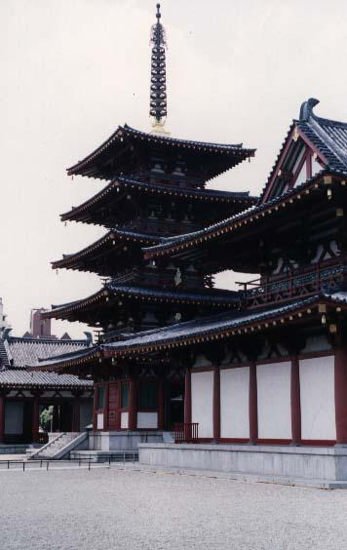
Stay At A Buddhist Temple. According to tradition, anyone, whether they be criminals, battered women, or enemy soldiers, was able to throw their shoes over the gate of a Buddhist temple and be granted sanctuary. Unless you possess earnest interest in learning about the faith and are possibly willing to shave your head, this may not be the most ideal way to find lodging, but even if it's only for a night you can experience a true other world. Even if you don't stay there, you want to buy omikuji (fortunes written on little slips of paper). If you get good luck, be happy and expect to open bombs in your future boosters. If you get poor luck, you have the option of tying the omikuji to a tree branch so that the wind can blow away your ill fortune. (An oracular mulligan, as it were.)
Watch Training At the Budokan. Located on the grounds of the Emperor's Gardens, the Budokan hosts dozens of Japan's martial arts tournaments every year. Get there early, around 5-8 AM or so, and check it out as you watch young men and women training to excel. Also be sure to observe the staffers go through their morning exercises; this is a picturesque place to watch a most Japanese company practice. Cost: Free, but budget your sleep schedule.
Participate in Sado (Tea Ceremony). Do you think Magic is a pastime with complicated rules? Then you ain't seen nothin' yet! Originally a formal show of wealth, worldliness, and sophistication of the 14th century aristocracy, Sado incorporates a wide number of traditional Japanese arts, including calligraphy, poetry, architecture, etiquette, and flower arrangement, and combines them with caffeine. Disciples usually study for decades before becoming accredited. You'll want to put at least an hour of study prep into this activity, but it's truly a fantastic way to experience Japan's tradition. Call the Kenkyusha Eigo Center (03-5261-8940) to get one-off lessons in English. While the lesson costs 5000 yen, that's a bargain for the experience.
Feed Pigeons at Senso-Ji. There are hundreds of tiny shrines and temples nestled in the concrete maze of Tokyo; if you only go to one, go to Senso-ji in Asakusa. Located 3 minutes' walk from the nearest subway station, Senso-ji boasts a huge number of mostly docile, friendly pigeons who will eat morsels from your hand, while resting all over your body. Watched over by the twin guardians Raijin and Fujin, the site offers both a decent sized Buddhist temple and a Shinto shrine. Smell the incense; clap your hands and offer a prayer, or buy crafts from the stalls that line the way towards the temple.
Stay at a Ryokan (traditional inn). While not especially roomy or offering lots of modern conveniences, a ryokan embodies Japanese dignity and reserve. Sleep on futons on comfortable tatami. Remember not to wear your shoes on the tatami, though. It's a great feeling to wake up to the sun shining in, surrounded by rice paper walls. I highly recommend staying at Ryokan Mikawaya (03-3843-2345), located about 2 minutes away from Asakusa's temples. The owner speaks good English and the rates are reasonable (7000 a night per person, including use of a yukata and traditional bath).
On the other hand, not everyone's interests lie in history and tradition. Do the ideas of Zen and bonsai bore you? If so, consider these few examples of the modern wonders of Tokyo.
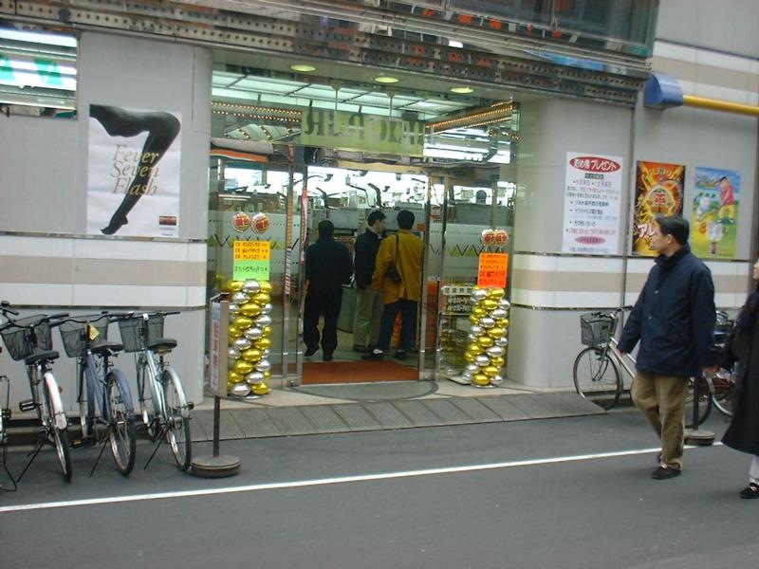
Play Pachinko. Lots of people enjoy hitting the casinos; Pachinko is a highly addictive, lower-stakes form of gambling. I've heard it described as vertical pinball, but nothing could be further from the truth. The player launches battalions of spring-projected balls towards a myriad of targets that earn you more balls. Timing, luck, and skill can lead to big success in this extremely popular pastime. Each machine has a small video screen that can flash into action with extremely amusing animation as it goes for a slot machine style payoff shot. Watch late night Japanese TV and you'll get the chance to watch well known Pachinko pros go at it and expound on the hilarious video chances. Beware: You may catch lung cancer from second hand smoke in a 20-minute bout.
Explore the Sony Building. Are you a worshipper of the Goddess of Tech? (No, not finding broken cards) Do you need to make a pilgrimage to the House of the Holy Circuit? Then go to the Sony building right next to the Ginza subway station at Sukiyabashi crossing. There are video games, VR tech, a TV studio, and enough beyond cutting edge consumer electronics to make an audiophile, videophile, or general techie lose their mind. Admission is free, open 11 to 7. For car buffs, a number of auto showrooms are in the neighborhood, so make your stroll of the Ginza a leisurely one.
Stay In A Coffin Hotel. If you're adventurous, want to affordably stay in the downtown of Tokyo and are not an NBA player, why not try staying in a coffin hotel? The operative word here is "small." While the guidebooks use the more discreet term "capsule hotel," I feel the term is disingenuous. You'll have better bragging rights if you use "coffin hotel" anyway. The tiny little space offers a bed, reading light, TV, alarm clock, and an extremely cramped human being. Stretching is not an option. Shower facilities are available. While I wouldn't recommend a stay longer than a single night, this is an extremely memorable way to experience Tokyo. (Warning: Most coffin hotels do not permit women to stay there. Like youth hostels, only cash is accepted.)
Play Video Games. Yes, you can play video games at home, but seldom with the luxury of the Japanese arcade. Most machines are sit down, ashtrays are everywhere for the smoke-inclined, and you can face your opponent who is sitting opposite from you on a linked machine. This is the way God intended video games to be played. Most games have English instructions. For the athletically inclined, Dance Dance Revolution and its later versions provide an incredibly fun workout. Musical types will enjoy the myriad rhythm games, from Samba De Amigo (shake those maracas!) to Crack'n DJ (your only controls: 2 turntables and a cross fader) to Drum Mania (yes, hit color coded drums in time to the falling notes on the screen). The Drum Mania and Guitar Mania machines are linked together, so you can have a virtual drum and 2 guitar combo all jamming together! Also note the ingenious sticker printing machines known as Print Club. The kitschy overlays will well be worth the momentary embarrassment.
Buy Omiyage. Omiyage are souvenirs to be given to coworkers and family after you return to your home. Japan is a fantastic place to buy knick-knacks. From random toys out of the "gatcha-gatcha" 200 yen vending machines to paper fans, from origami supplies to happi coats, you'll be sure to find something to delight your loved ones who stayed home. Tokyo shopping is hectic, crowded, and challenging. But with luck, you'll come home a winner regardless of how your Magic games go.
If you're anticipating buying a kimono for yourself or a loved one, be prepared to fork over about 200 USD at the very minimum. Kimono are also rather difficult to wear; I strongly advise buying a happi coat or yukata, as they are cheaper, easier to wear, and take up less suitcase space.
For fellow Magic players, I strongly recommend the Di Gi Charat deck holders. They're tough, affordable, and undeniably cute. Japanese card sleeves are also affordable, durable, and attractive.
Keep in mind this is the tip of the iceberg here; Tokyo's a happening place. While I'm not the Japan Board of Tourism, feel free to email me if you have any further questions. I hope that these recommendations will make your PT: Tokyo trip as much fun as possible. It takes a little effort to have a great time in Tokyo, but rest assured that effort you're making will give you fond memories you'll be able to tell your grandkids about someday.

